Asia Pacific College
School of Computer Science and Information Technology
Software Development

User Manual for Fulbright Science School Assistance Program
(Website)

Prepared by:
Ayson, Ronald Martin
Tabudlong, Jhun Michael

Table of Contents
I. System Overview 3
1.1 Application 3
1.2 Dialog Flow 3
1.3 User Account and Privacy 3
1.4 User Operation Manual 4

I. System Overview
The Fulbright Science School Assistance Program provides a website that showcase the school’s facilities, the programs of the school for the incoming students.

1.1 Application
The system is composed of two parts the frontend and the backend.
Within the frontend lies everything that the student and parents need to see, the school’s enrollment procedure, how to inquire, what to expect when they enroll their child in the school. The frontend also has a gallery to show the audience the school’s facilities, equipment, and other areas of the school.

In the backend, there is an administrator account which has two options. To create another user, this feature was not fully developed because the grading system was not continued. The second feature where the admin can edit pictures from the backend that would reflect to the frontend. The admin can upload pictures, which would reflect from the frontend, can edit, and delete pictures.

1.2 Dialog Flow
For the frontend the user needs to enter the URL of the website.

For the backend the administrator needs to have a user account (login and password) credentials to be able to edit, update, upload and delete from the gallery.

1.3 User Account and Privacy
Administrator Account – handles all the changes that can be made on the frontend from the backend, the admin can change the pictures of the gallery.

1.4 User Operation Manual
- For the frontend
Main Home Page

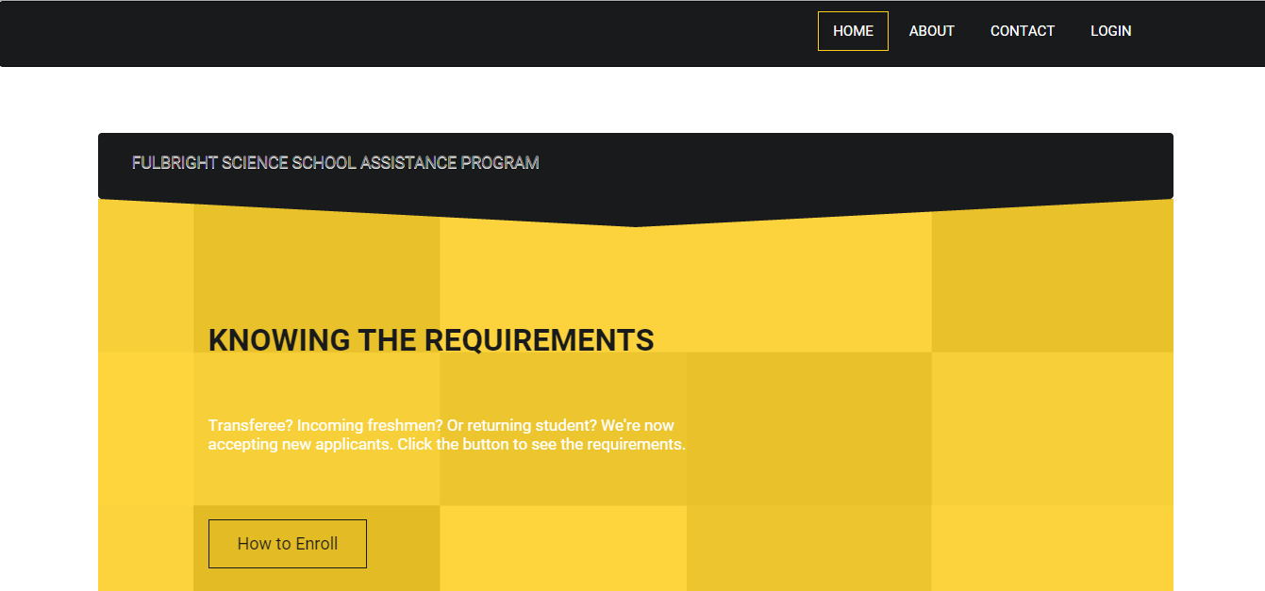

Enrollment Procedure

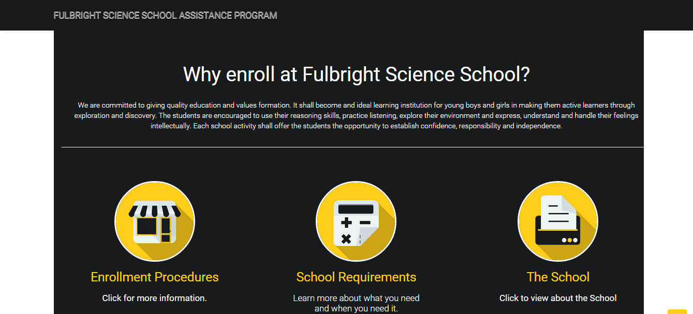

More detailed enrollment procedure
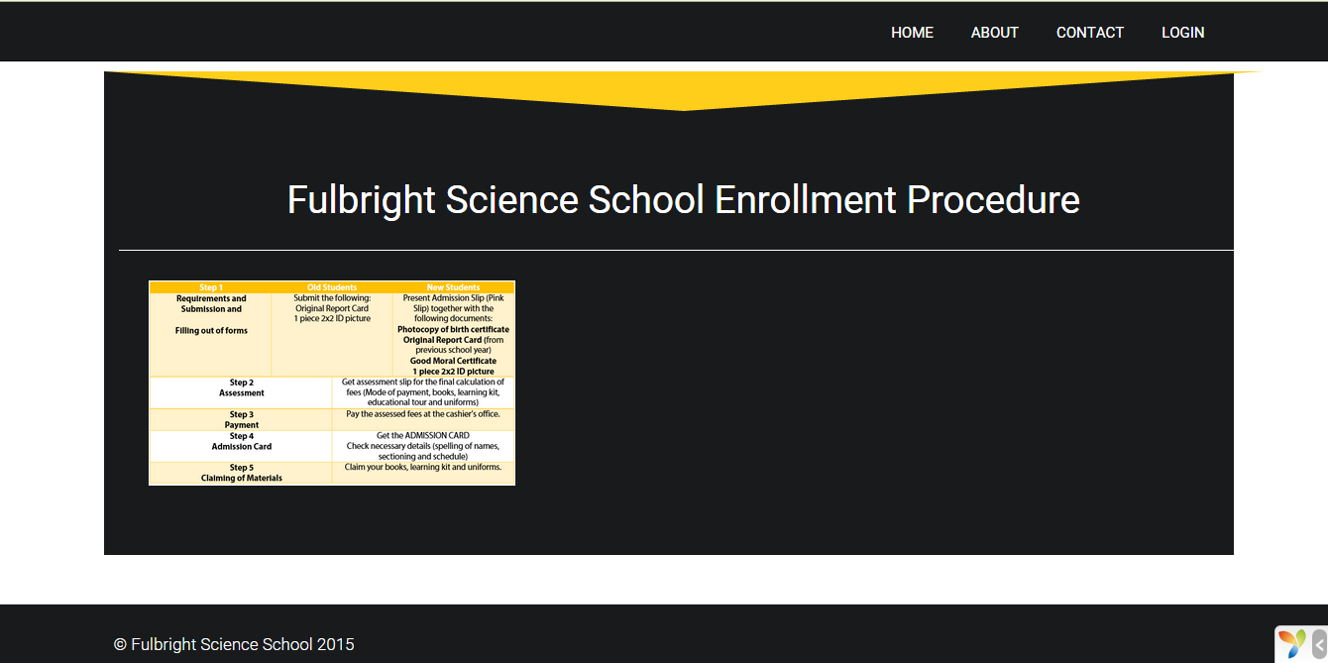

Gallery Page



About Us
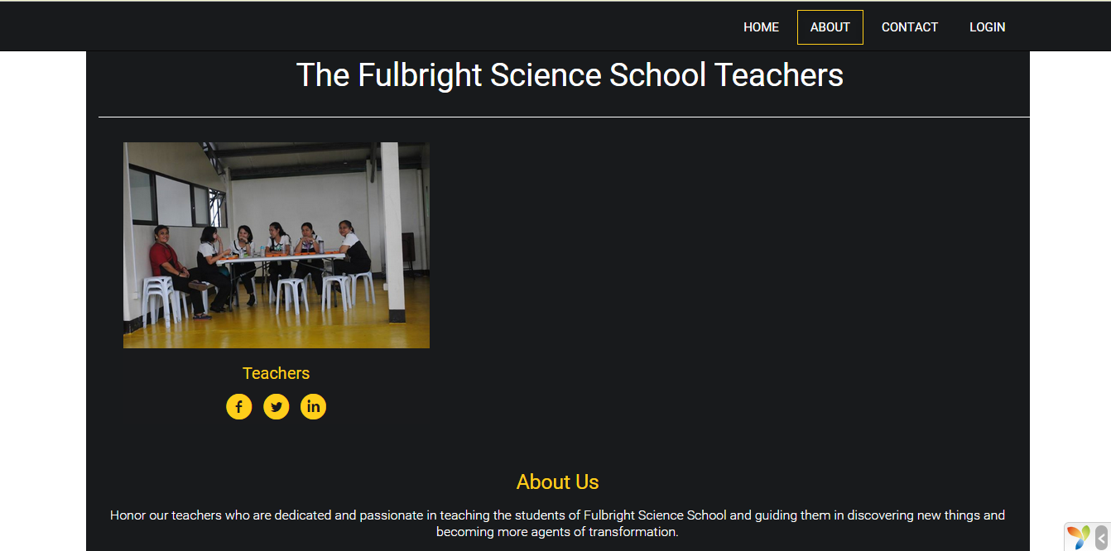

Contact Us
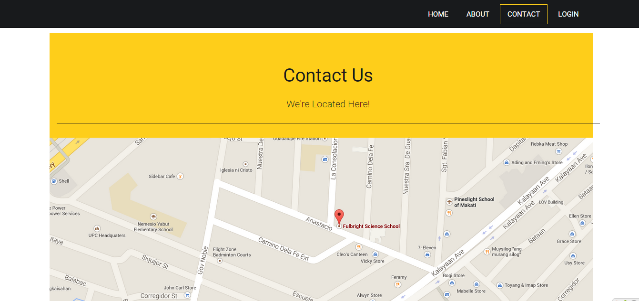

- For the Backend
Login for the Backend

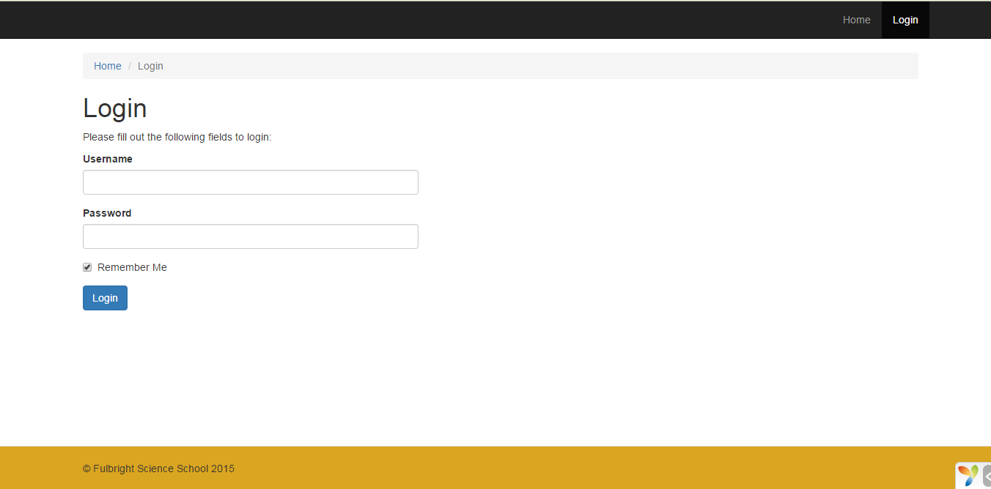

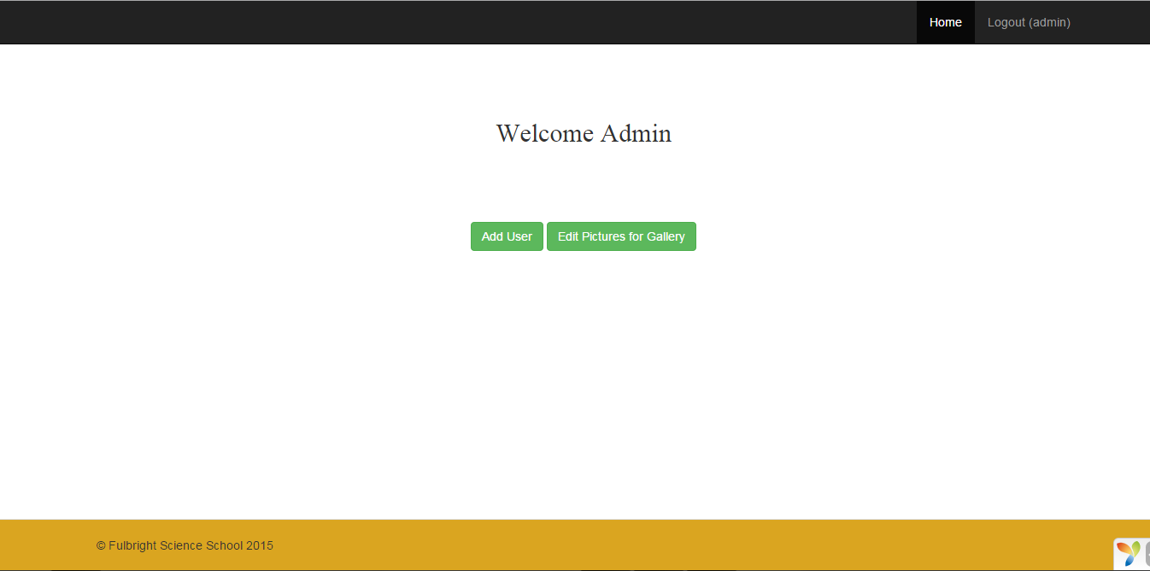

Account creation page
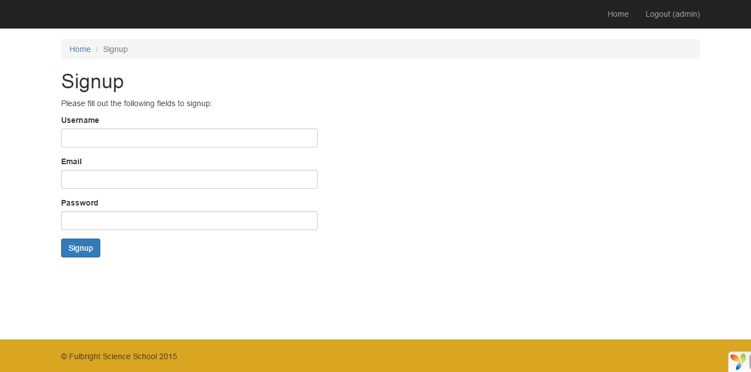

Function from the backend. (Working)
Upload image from the backend that would reflect to the frontend.

1. Create Edit Gallery pictures from the admin home page.
2. Press the “Create Gallery Button”
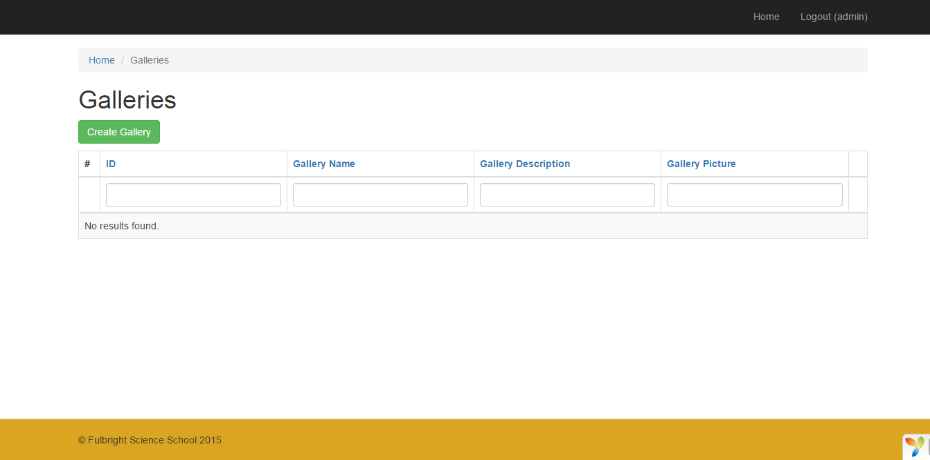

3. Fill up the desired Image name, image description and choose the file to be uploaded.
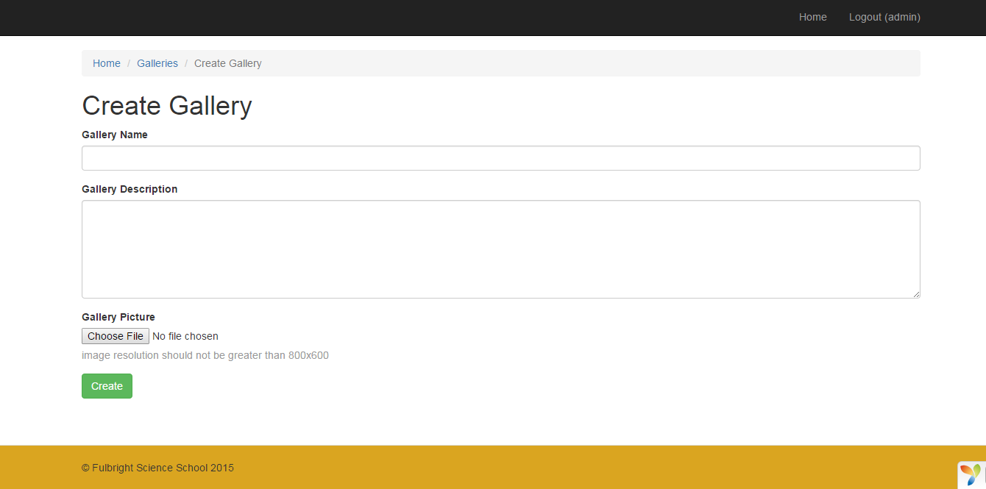

4. After you fill up the name, description and have chosen the image to be uploaded. Press the create button.
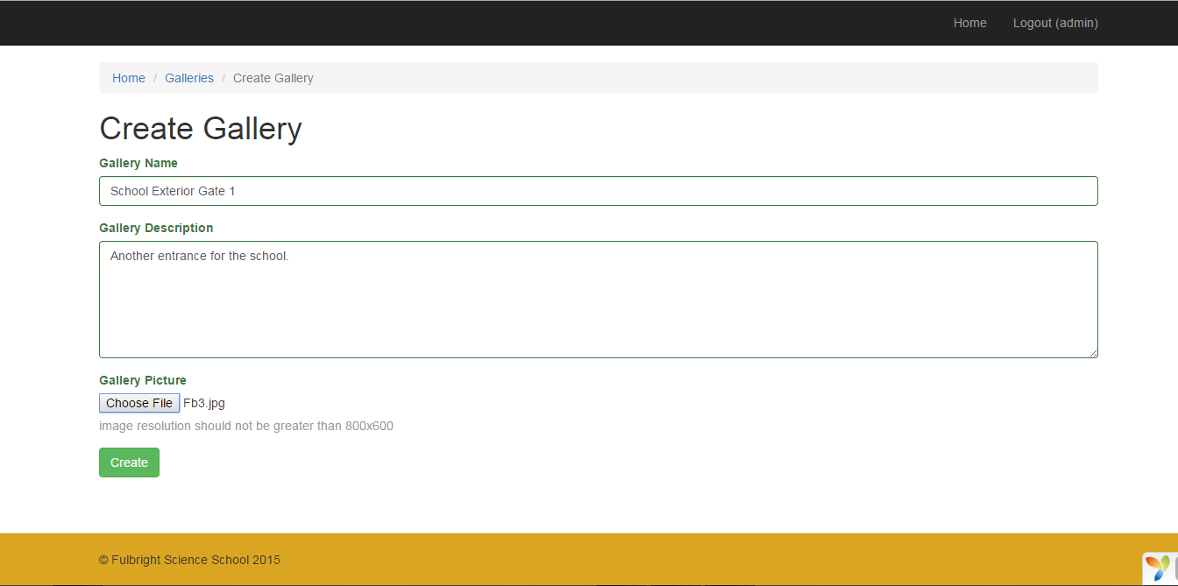

5. Then it would display a page of the image you have created for the frontend page.

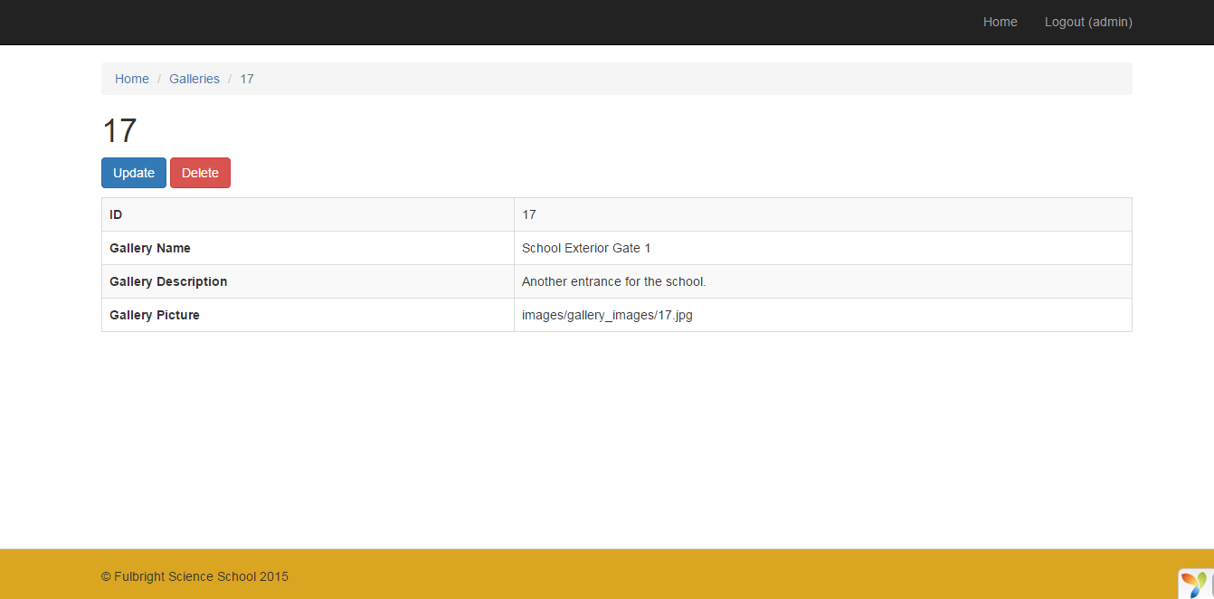

6. Check the frontend for changes.

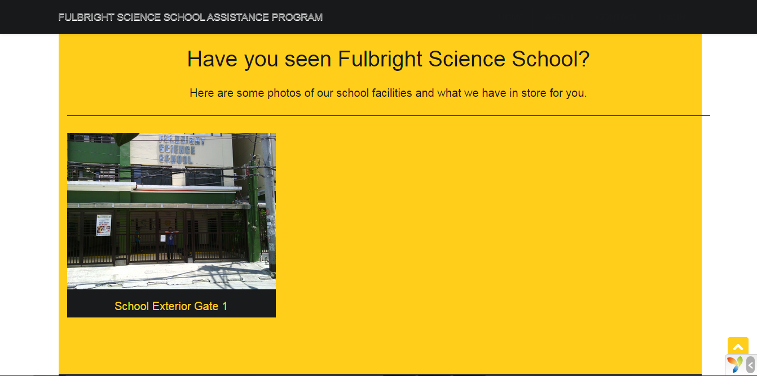

The image you’ve uploaded will now reflect on the frontend for the students, parents and those audience who wants to inquire for the school.

